**Thomas Flynn**

**G00291875**

**12/11/15**

**Sprint 2: Week 3 Log**

**Update:**

Today marks the end of my 2nd sprint for my final year project. So far I'm happy with my progress. I achieved my primary objective for this sprint which was to get my Android platform talking to my Desktop application through Bluetooth.

Using the JavaFX tutorials I was able to programme a basic music Player using the JavaFX API. For the third Sprint I hope to have my server code running concurrently with my JavaFX music player code.

I Have divided my work into 4 different repositories on Github. In hindsight I should have put these into separate branches within a single repository.

**Links to my GitHub Repositories:**

[FYP-Server](https://github.com/g00291875/FYP-Server)

[FYP-Android](https://github.com/g00291875/FYP-Android)

[FYP-GUI](https://github.com/g00291875/FYP-GUI)

[FYP-Database](https://github.com/g00291875/FYP-Database)

**Links to source code examples used:**

[**Bluetooth-Chat-Android**](https://github.com/marcuspimenta/Chat-Bluetooth-Android)

[**Bluetooth server**](http://luugiathuy.com/2011/02/android-java-bluetooth/)

**Research done:**

[JavaFX tutorial](https://www.youtube.com/watch?v=FLkOX4Eez6o)

**Tasks completed:**

Client receives response string

JDBC tutorial

JavaFX tutorial

Server code displaying in textArea

JavaFX music Player working

**Board at the start of the week:**

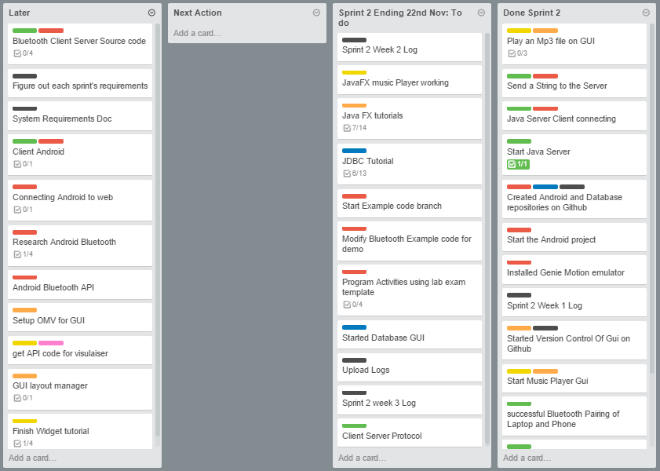

**Board at the end of the week:**

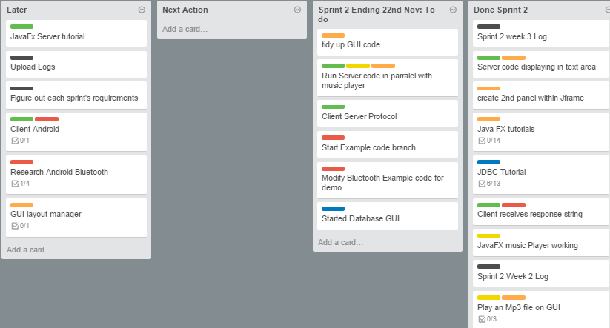

**Weekly time Log bar chart:**

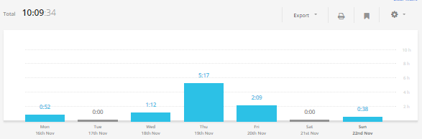

**Weekly Time Log:**

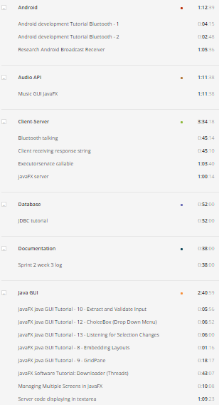

**Weekly log Pie Charts:**

